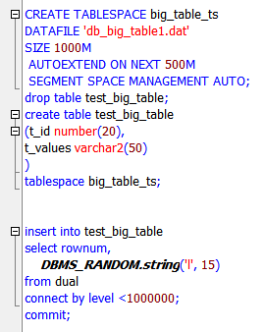

**Task 01: CREATE Example of Select Parallel execution**

|  |  |  |
| --- | --- | --- |
| Without parallel |  |  |
| With parallel |  |  |

**Task 02: CREATE Example of Parallel DML**

|  |  |  |
| --- | --- | --- |
| Without parallel |  |  |
| With parallel |  |  |

**Task 03: CREATE Example of Parallel DDL**

|  |  |  |
| --- | --- | --- |
| Without parallel |  |  |
| With parallel |  |  |